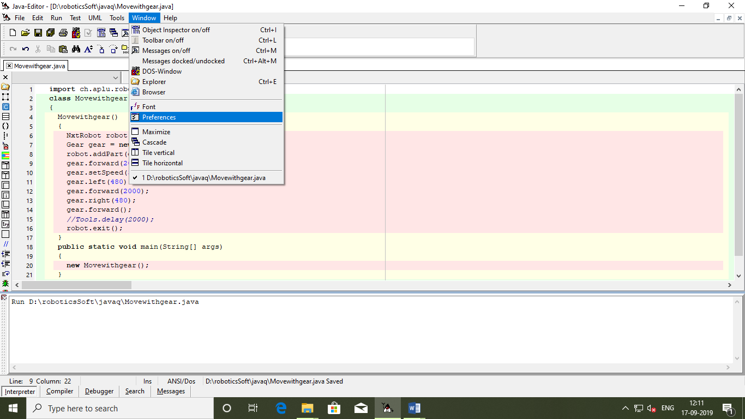

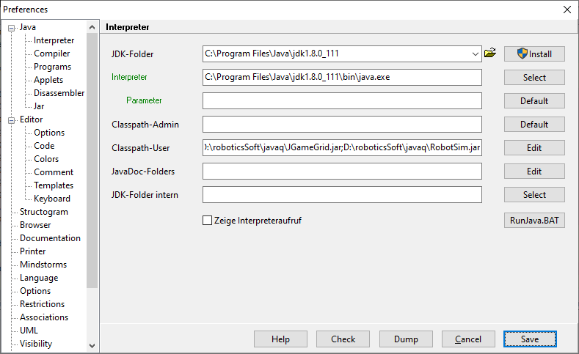

import ch.aplu.robotsim.\*;

class Movewithgear

{

Movewithgear()

{

NxtRobot robot = new NxtRobot();

Gear gear = new Gear();

robot.addPart(gear);

gear.forward(2000);

gear.setSpeed(30);

gear.left(480);

gear.forward(2000);

gear.right(480);

gear.forward();

//Tools.delay(2000);

robot.exit();

}

public static void main(String[] args)

{

new Movewithgear();

}

}

